**CS2023 - Data Structures and Algorithms**

**In-class Lab Exercise**

Week 12

Name: A.A.H. Pramuditha

Index: 200476P

**Question 1**



|  |  |  |  |  |  |  |
| --- | --- | --- | --- | --- | --- | --- |
|  | **0** | **1** | **2** | **3** | **4** | **5** |
| **0** | 0 | 10 | 0 | 0 | 15 | 5 |
| **1** | 10 | 0 | 10 | 30 | 0 | 0 |
| **2** | 0 | 10 | 0 | 12 | 5 | 0 |
| **3** | 0 | 30 | 12 | 0 | 0 | 20 |
| **4** | 15 | 0 | 5 | 0 | 0 | 0 |
| **5** | 5 | 0 | 0 | 20 | 0 | 0 |



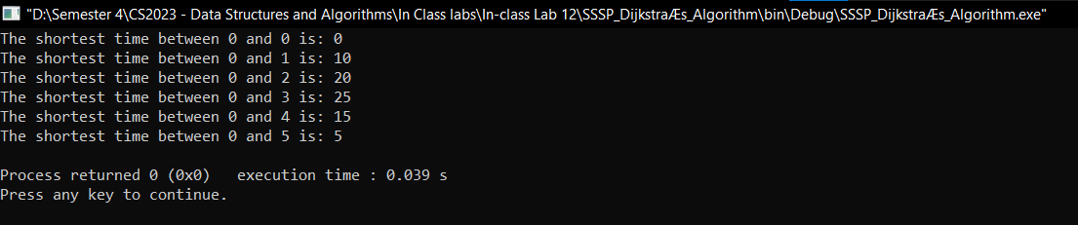

* Average time for city 0: $\frac{10+20+25+15+5}{5}$ = 15
* Average time for city 1: $\frac{10+10+22+15+15}{5}=14.4$
* Average time for city 2: $\frac{20+10+12+5+25}{5}=14.4$
* Average time for city 3: $\frac{25+22+12+17+20}{5}=19.2$
* Average time for city 4: $\frac{15+15+5+17+20}{5}=14.4$
* Average time for city 5: $\frac{5+15+25+20+20}{5}=17$

According to these calculated values, 1, 2, and 4 cities have the shortest average time for other cities. So, they are the most suitable cities to place the hospitals so that ambulances can reach other cities in a short time.

Link to the Git hub repository: [hashirupramuditha/CS2023---Data-Structures-Algorithms (github.com)](https://github.com/hashirupramuditha/CS2023---Data-Structures-Algorithms)